**5. PROJECT PLANNING & SCHEDULING**

|  |  |
| --- | --- |
| Date | 29-05-2025 |
| Team ID | LTVIP2025TMID28829 |
| Project Name | Medical Inventory Management |
| Maximum Marks | 5 Marks |

**5.1 Project Plan (Gantt Chart)**

**Introduction**

The success of any software implementation project depends significantly on effective planning and time-bound execution. For the **Medical Inventory Management System** built on Salesforce, a structured timeline ensures that key phases like requirement gathering, development, testing, and deployment are executed in a well-coordinated manner. To visualize and track progress, we have developed a **Gantt Chart** that outlines major milestones across the project lifecycle.

**Project Duration**

* **Start Date:** January 2025
* **End Date:** September 2025
* **Total Duration:** 9 months

The project is divided into 10 key phases, each with dependencies on preceding tasks. Activities have been scheduled with enough buffer to accommodate review cycles, testing iterations, and change requests.

**Key Phases & Activities**

| **Phase** | **Duration** | **Description** |
| --- | --- | --- |
| **1. Requirement Analysis** | Jan – Feb | Understanding hospital workflows, identifying pain points, preparing use cases |
| **2. System Design** | Feb – Apr | Data modeling, ER diagrams, DFDs, UI planning, architecture definition |
| **3. Development** | Mar – May | Building Salesforce objects, automation, validation, and Lightning pages |
| **4. Testing** | Apr – Jun | Functional testing, bug fixing, and UAT (User Acceptance Testing) |
| **5. Deployment** | May – Jul | Final deployment to production org, configuration, integration setup |
| **6. User Training** | Jun – Aug | Hands-on sessions for inventory managers and procurement officers |
| **7. Documentation** | Jul – Aug | User manuals, process documentation, system architecture handoff |
| **8. Review & Feedback** | Aug – Sept | Collection of feedback, minor changes, performance tuning |
| **9. Project Closure** | Sept | Final approval, project report submission, success review |

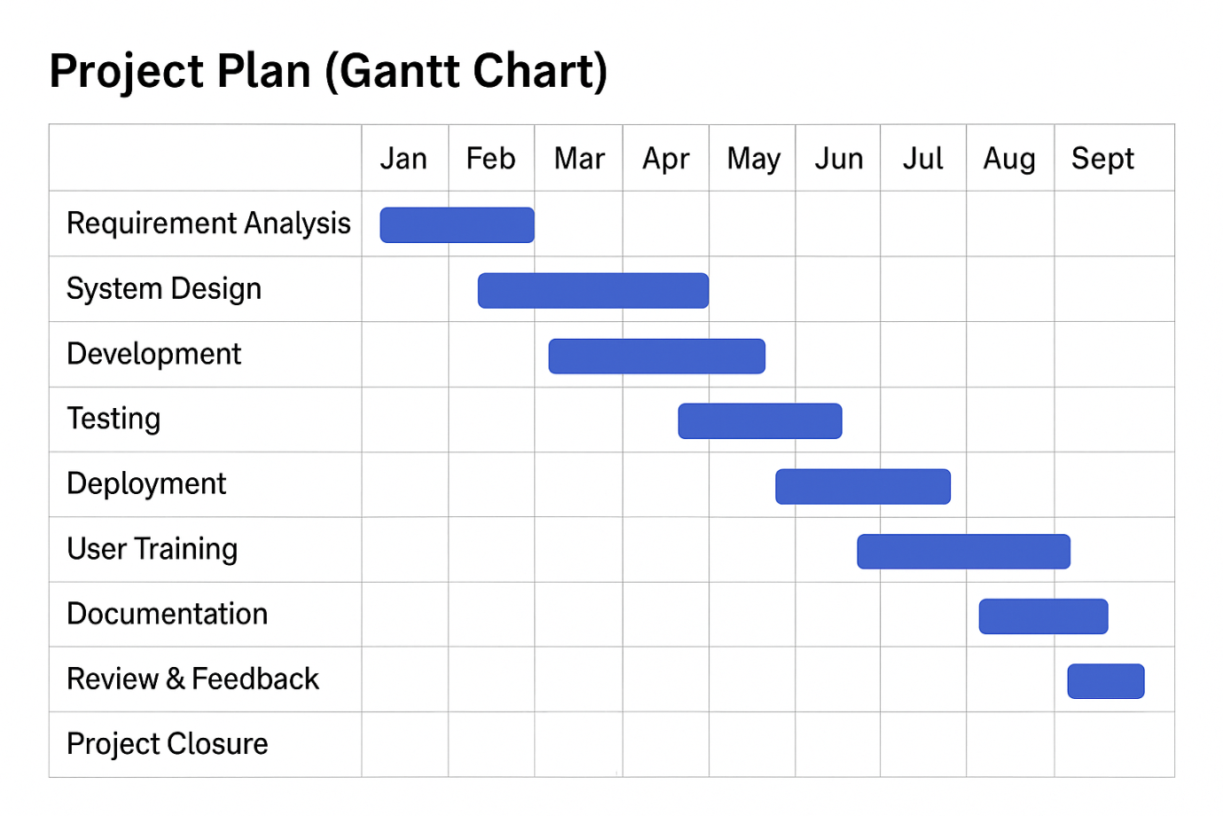

**Gantt Chart Representation**

(See Gantt chart image above)

The Gantt chart visualizes each task as a horizontal bar along a timeline, with overlapping periods representing parallel development or concurrent testing. For example:

* Development begins in March but overlaps with design finalization.
* Testing starts mid-way through development to adopt an **agile and iterative** testing cycle.
* Deployment and training occur concurrently, ensuring readiness without delays.

**Dependencies & Risk Management**

* **Dependency 1:** Testing depends on partial development completion.
* **Dependency 2:** Training is dependent on successful UAT results.
* **Dependency 3:** Documentation starts only after core features are stable.

To mitigate risks:

* Weekly sprint reviews and internal demos are conducted.
* Buffer time is added before critical milestones like deployment and closure.
* Slack time is included in documentation and feedback phases for flexibility.

**Tools Used for Scheduling**

* **Project Tracking Tool:** Trello for task-level management
* **Gantt Chart Tool:** Microsoft Excel & Lucidchart for timeline visualization
* **Sprint Management:** Agile board in Jira (optional for team collaboration)

**Conclusion**

The structured planning reflected in the Gantt chart ensures systematic development and delivery of the Medical Inventory Management System. Adhering to this timeline allows the team to maintain focus, adapt quickly to changes, and deliver a reliable, user-ready Salesforce solution for hospital inventory control.

Let me know if you'd like the editable Gantt chart in .xlsx format for inclusion in your project submission.